**Install – Jenkins**

The leading open source automation server, Jenkins provides hundreds of plugins to support building, deploying and automating any project.

* <https://www.jenkins.io/doc/book/installing/linux/> for installing jenkins on linux
* Ubuntu steps: <https://www.jenkins.io/doc/book/installing/linux/#debianubuntu>

sudo apt update

sudo apt install openjdk-17-jdk -y

curl -fsSL https://pkg.jenkins.io/debian-stable/jenkins.io-2023.key | sudo tee \

/usr/share/keyrings/jenkins-keyring.asc > /dev/null

echo deb [signed-by=/usr/share/keyrings/jenkins-keyring.asc] \

https://pkg.jenkins.io/debian-stable binary/ | sudo tee \

/etc/apt/sources.list.d/jenkins.list > /dev/null

sudo apt update

sudo apt install jenkins -y

Navigate to http://<public-ip>:8080  
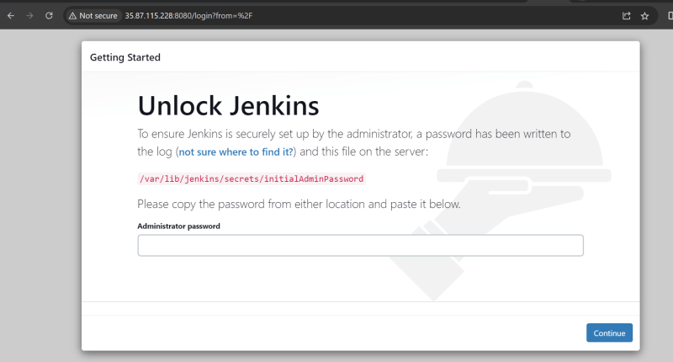

* findout the initial Admin password

sudo cat /var/lib/jenkins/secrets/initialAdminPassword

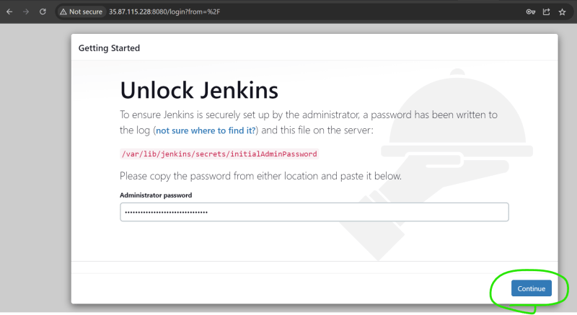  
* Now install suggested plugins  
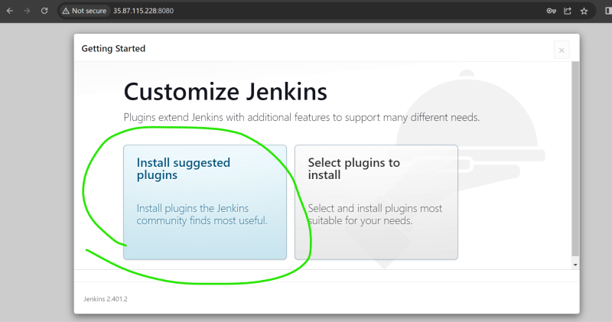  
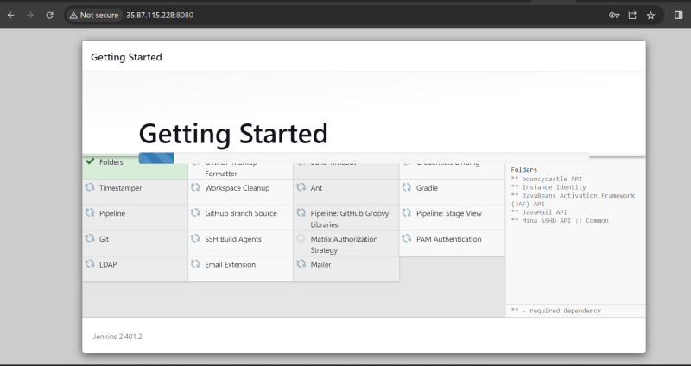  
* Create a new admin user  
  
